**Name:DevaS**

**192210100**

**13.Create a simple cloud software application for Car Booking Reservation System using any Cloud Service Provider to demonstrate SaaS include the necessary fields such as search for cabs, from, to, rental , out station, Package type, hours/Days etc.**

**Step 1:**

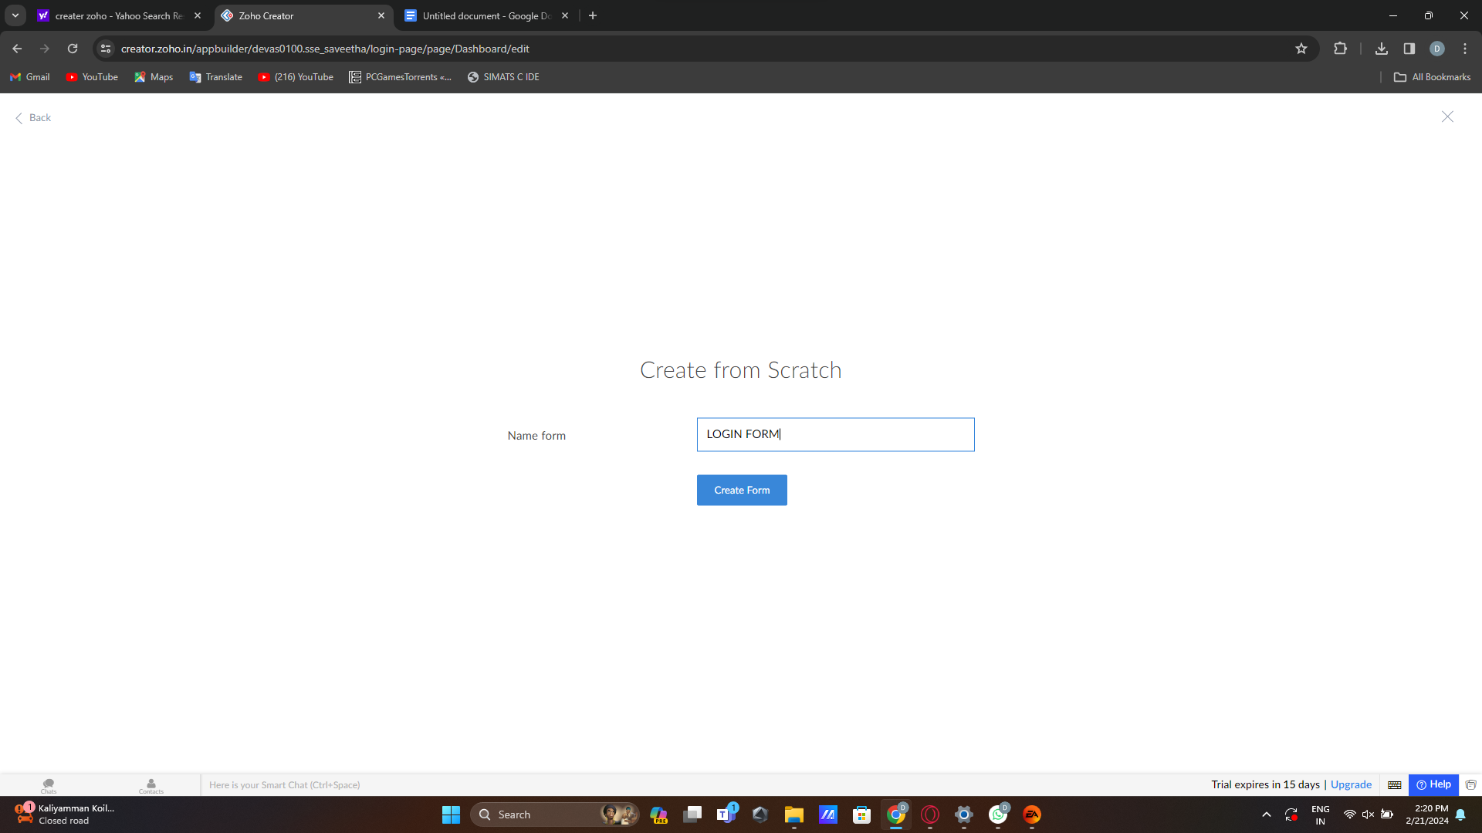

**Step 2:**

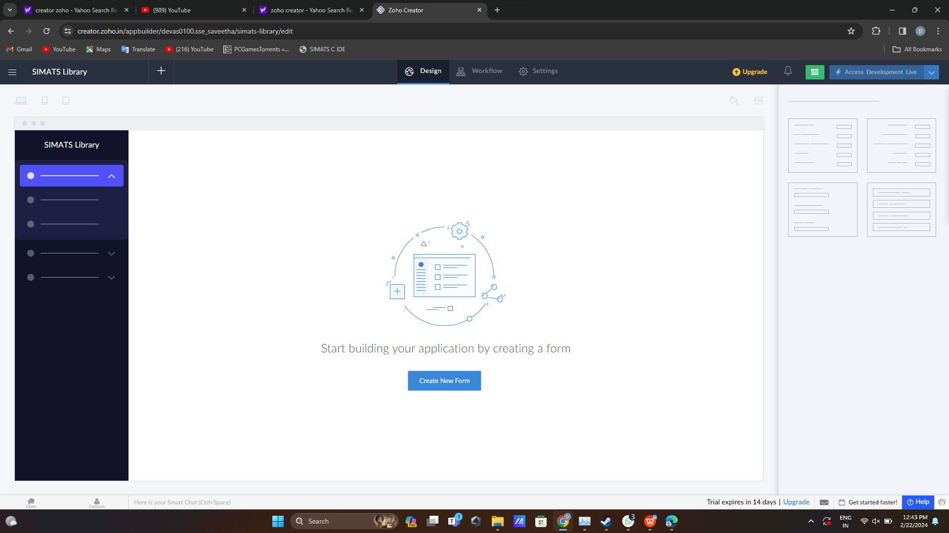

**Step 3:**

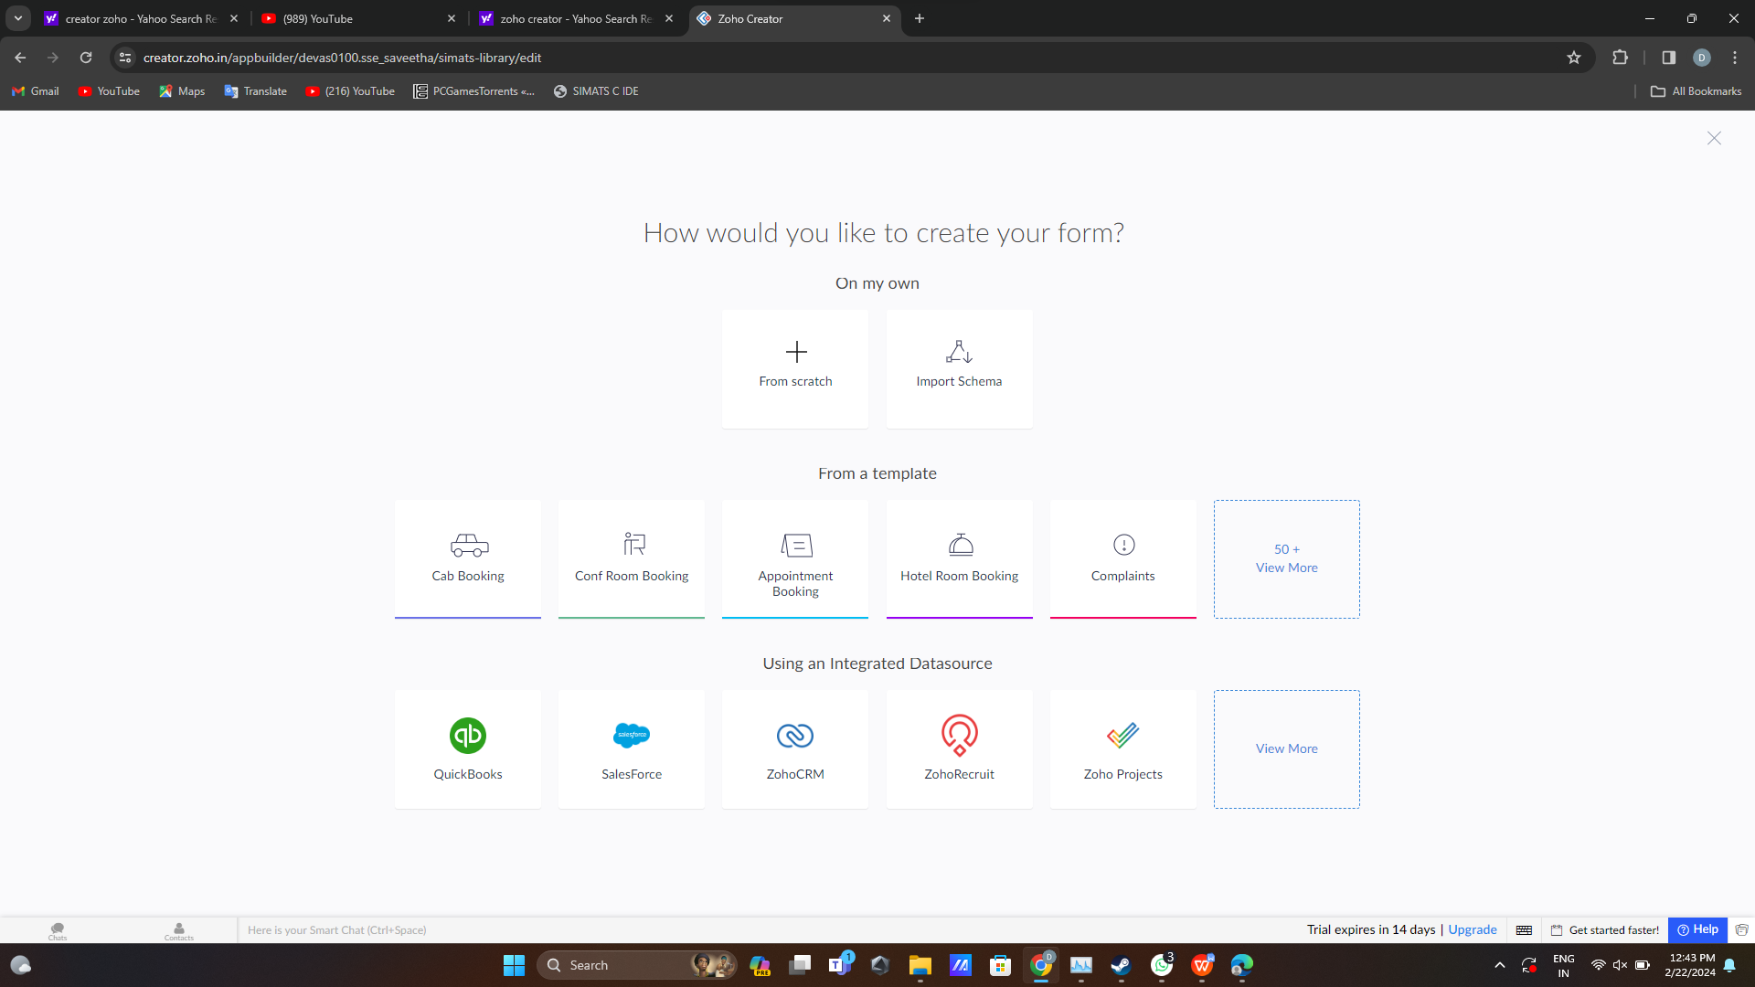

**Step 4:**

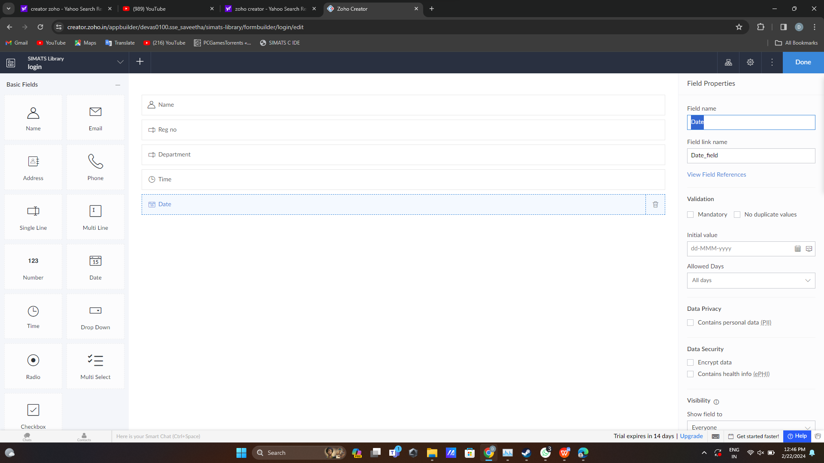

**Step 5:**